**P530/2**

**BIOLOGY**

**(Theory)**

**Paper 2**

**Jul /Aug 2019**

**2 ½ Hours**



**MUKONO EXAMINATION COUNCIL**

**Uganda Advanced Certificate of Education**

**BIOLOGY**

**Paper 2**

**2hours 30 minutes**

**INSTRUCTIONS TO CANDIDATES**

*This paper consists of* ***six*** *questions.*

*Answer* ***one*** *in section* ***A*** *plus* ***three*** *others from section* ***B****.*

*Candidates are advised to read the questions carefully, organize their answers and present them precisely and logically, illustrating with well labelled diagrams where necessary.*

**SECTION A (40 MARKS)**

1. 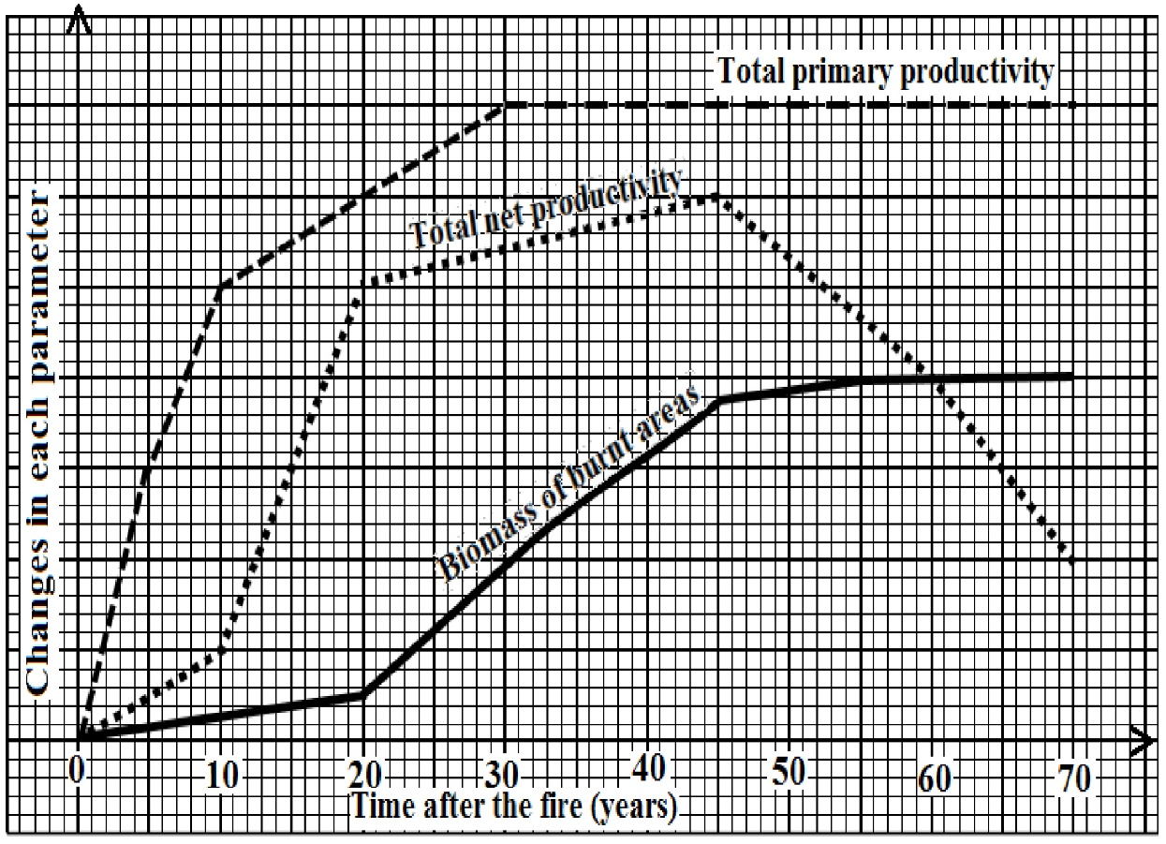The figure below shows the effect of fire on the changes in total primary production, total net productivity and biomass of the area after recovery
2. Compare the relationship in the trend of biomass and total net productivity **(*04 marks*)**
3. Explain the changes in each of the following during the period of investigation
4. total primary productivity **(*10 marks*)**
5. total net productivity **(*08 marks*)**
6. biomass **(*05 marks*)**
7. Explain the relationship between total net productivity after 45 years with;
8. total net productivity **(0*3 marks*)**
9. biomass **(0*2 marks*)**
10. Suggest and explain what would happen to the total net productivity if the area was invaded by many herbivores.  **(*04 marks*)**
11. What is the ecological significance of fire on an ecosystem?  **(*04 marks*)**

***SECTION B***

2. a) Differentiate between osmosis and active transport  ***(06 marks)***

b) Explain how the mass flow accounts for the transport of water in plants. ***(10 marks)***

c) What are the challenges of mass flow to the translocation in the phloem ***(04 marks)***

3. a) Compare the action of auxins and gibberellins in higher plants.  ***(12 marks)***

b) Explain the effect of light interruptions on flowering.  ***(08 marks)***

4. a). Describe the structure of an enzyme.  ***(06 marks)***

b). How is the structure of the cell membrane proteins related to their function? ***(08 marks)***

c). Explain the factors that cause denaturation of a protein.  ***(07 marks)***

5. a) Describe the process of metamorphosis in insects.  ***(06 marks)***

b) Explain the role of hormones in insect metamorphosis. ***(09 marks)***

c) What is the significance of metamorphosis in the life of an insect?  ***(05 marks)***

6. a) Explain the role of each of the following in evolution

1. Mutation ***(06 marks)***
2. Predation  ***(05 marks)***

b) How does the concept of development and distribution of Darwin’s finches explain evolution? ***(09 marks)***

**END**